**DebateVerse Project Overview**

DebateVerse is a versatile online platform designed to encourage engaging and thoughtful debates on various topics. It allows users to initiate, join, and explore discussions covering multiple subjects. Each debate features a question accompanied by 2 to 7 choices (viewpoints) for users to vote on. Users can also like or dislike the questions, with all voting outcomes displayed visually to enhance clarity and engagement.

The project utilizes modern web technologies, such as React for the frontend, Node.js for the  
backend, and MySQL for managing data, ensuring scalability and interactivity for a thriving online community.

**Core Features**

* **Create Debates:** Users can start debates by specifying a question and adding 2 to 7 choices.  
  This diversity fosters a wide range of opinions and deeper discussions.
* **Voting System:** Each user has 10 votes to distribute among the options, reflecting varied  
  preferences. Voting results are presented graphically in real-time.
* **Search & Explore:** Users can easily discover debates by browsing topics, keywords, or  
  popular discussions and view vote distribution for selected debates.
* **Likes/Dislikes:** Users can express their sentiment towards debate questions by liking or  
  disliking them, adding another layer of interaction.
* **Admin Management:** Admins oversee the platform, closing debates post-conclusion,  
  moderating content, and ensuring respectful interactions.
* **Statistics:** Comprehensive data, such as vote counts per option and likes/dislikes, helps users gauge the popularity of viewpoints.

**Technology Stack**

* **Frontend:** React builds a responsive, interactive interface with reusable components and  
  state management for actions like voting and viewing statistics.
* **Backend:** Node.js and Express handle API requests for creating debates, casting votes, and  
  fetching data while ensuring smooth interaction with the database.
* **Database:** MySQL stores structured information, including user profiles, debate content, and  
  voting data, for efficient querying.

**Workflow**

* **User Signup/Login:** Secure authentication links actions like voting to individual accounts.
* **Debate Creation:** Users can post debates, which are stored in the database and made  
  available for public voting.
* **Voting:** Each debate reflects the voting progress in real-time with visual charts (e.g., bar or  
  pie).
* **Moderation**: Admins ensure discussions adhere to guidelines by closing debates, removing  
  inappropriate content, or flagging users if necessary.
* **View Statistics:** Post-voting, users can analyse statistics to understand viewpoint popularity  
  and community sentiment.

**Outcomes**

* **Engagement:** The platform fosters active participation and discussions among users with  
  diverse perspectives.
* **Clarity:** Real-time graphical vote distribution improves understanding of debates' progress  
  and viewpoints.
* **Moderation:** Admin tools ensure a safe, respectful environment.
* **Discoverability:** Search functionality expands access to a variety of discussions.

**Conclusion**

DebateVerse blends social interaction with organized debates, providing a seamless experience using React, Node.js, and MySQL. It promotes participation, transparency, and thoughtful dialogue while empowering moderators to maintain order. This project highlights how modern technologies can create scalable and engaging online platforms.

Some OutPuts:

Sign In

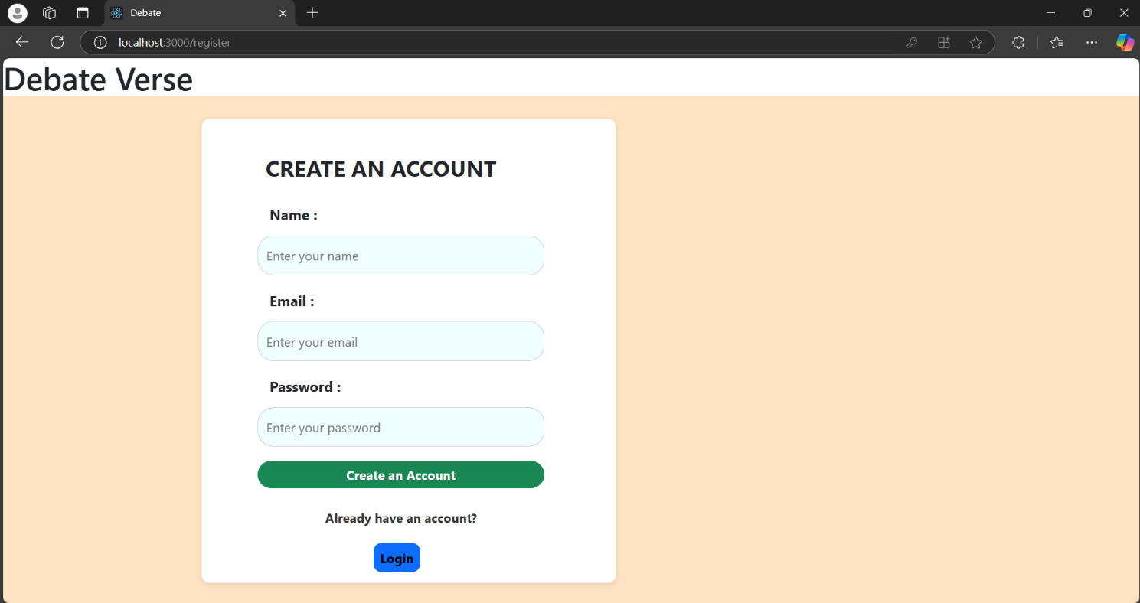

**Log In :**

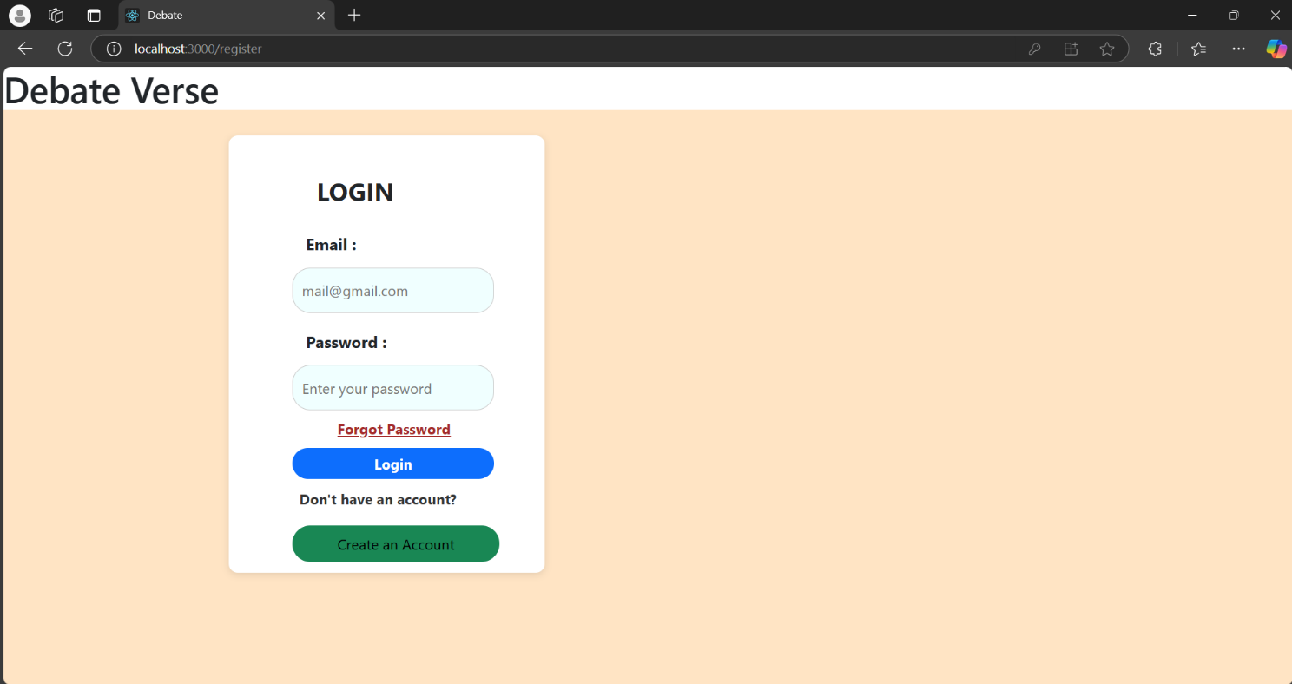

**Forgot Password :**

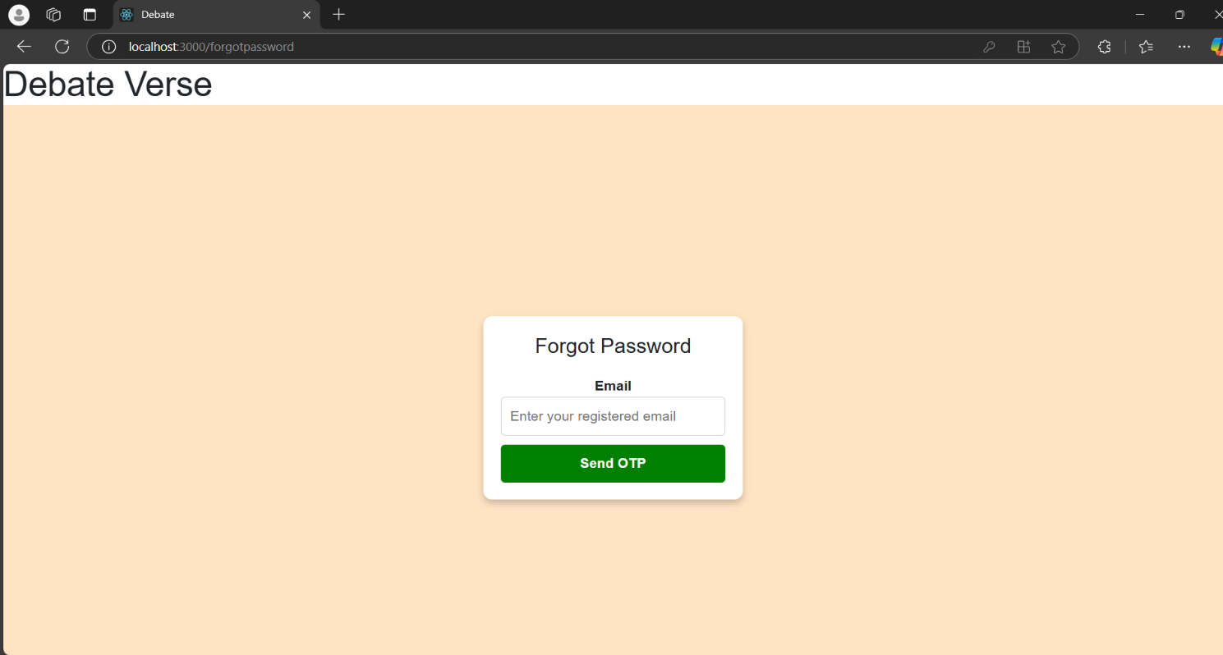

**Verify Opt :**

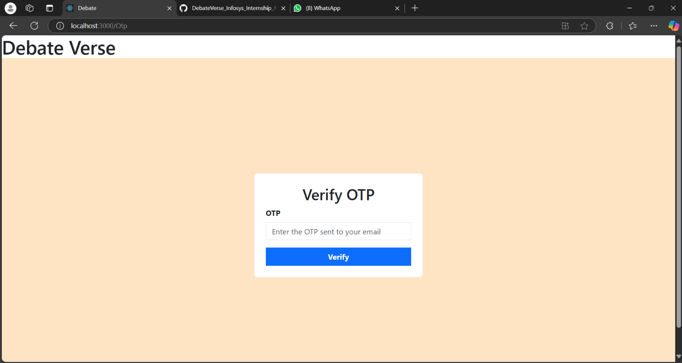

**Creating Debate :**

